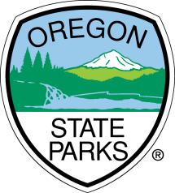
News Release

Oregon Parks and Recreation Department
FOR IMMEDIATE RELEASE
Release Date: March 4, 2022

Media Contact:
Kuri Gill, Oregon Heritage grants and outreach coordinator
503-383-6787, Kuri.Gill@oprd.oregon.gov
www.oregonheritage.org

Grants awarded for veteran and war memorial projects throughout the state

SALEM, Oregon –
Grants awarded for veterans and war memorials projects throughout the state
Oregon Parks and Recreation Department awarded four grants totaling $169,671 for projects across the state that create or preserve memorials to veterans or wars. Awards range from range from $12,552-$57,919.
Funded projects include:
- Install a memorial at City Hall in Aumsville.
- Phase two of the memorial in Happy Valley.
- Development of a new memorial park in Philomath.
- Enhance the flag site with a memorial at the cemetery in Prairie City.
This competitive grant program was created by the Oregon legislature in 2005. Applicants must be local or tribal governments and the memorial must be on public land.
For more information on the Veteran and War Memorials grant program, visit www.oregonheritage.org or contact Kuri Gill at Kuri.gill@oprd.oregon.gov or 503-986-0685.
# # #

###

