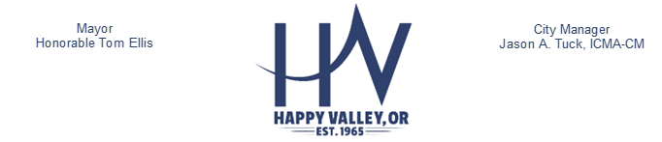
Date: May 13, 2026

Re: NOTICE OF AWARD

Project: Happy Valley Public Works Facility

The City of Happy Valley has awarded the contract for the Happy Valley Public Works Facility, Owner’s Representative Services to Specht Development, Inc. If you have any questions about this Notice of Award or about the project, please contact Dan Jung, Capital Improvement Program Manager at djung@happyvalleyor.gov.

16000 SE Misty Drive, Happy Valley, Oregon 97086-4288
Telephone: (503) 783-3800 Fax: (503) 658-5174
happyvalleyor.gov

Preserving and enhancing the safety, livability and character of our community

